Name : bhawwana shre
Hall no : 2304a52311
SUBJECT: AI ASSISTANT CODING
BATCH: 01

Task Description#2
>>use copilot to generate a is_prime() python function
Expected output#2
>>function to check primality with correct input
PROMPT:
>>Develop a python program to check a number prime or not

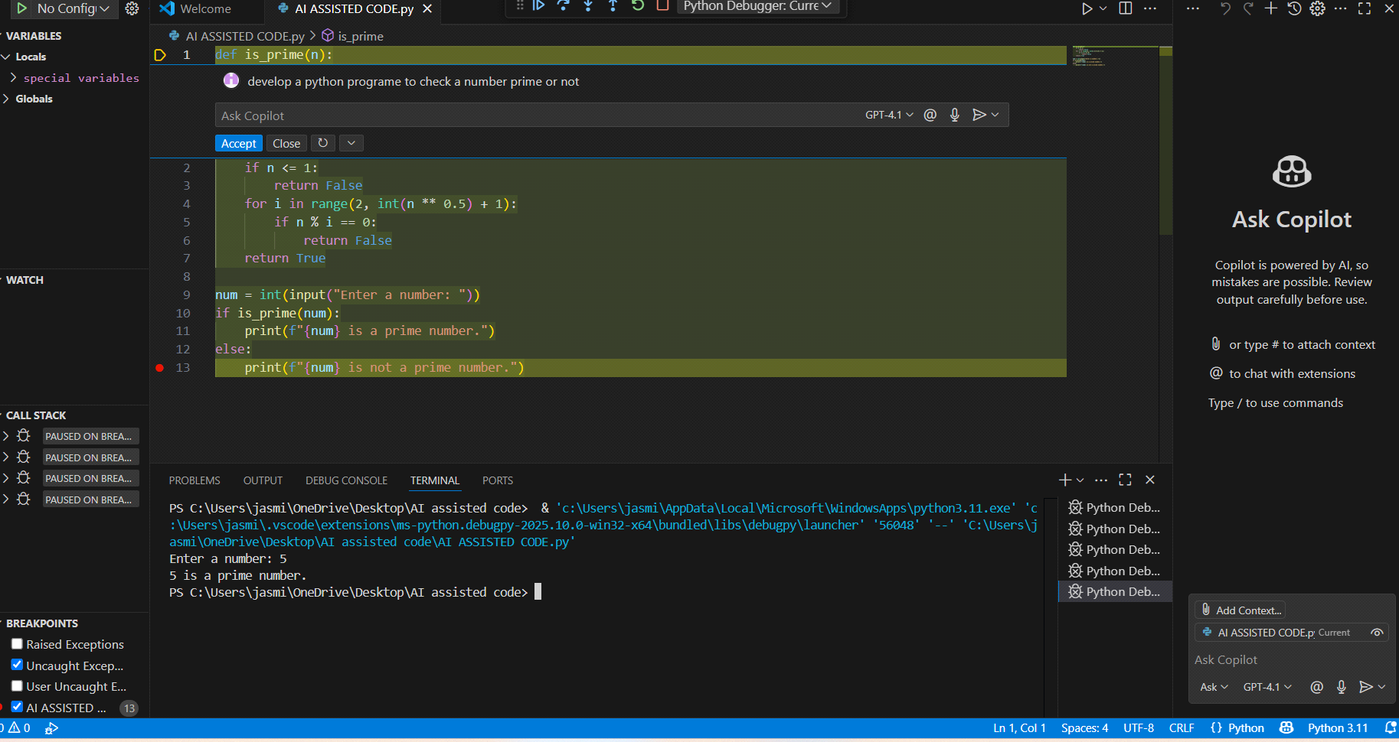

Task Description#3
>>write a comment like#function to reverse a string and use copilot to generate a function
Expected output#3
auto completed function
PROMPT:
Develop a python code to generate a comment like#function to reverse a string
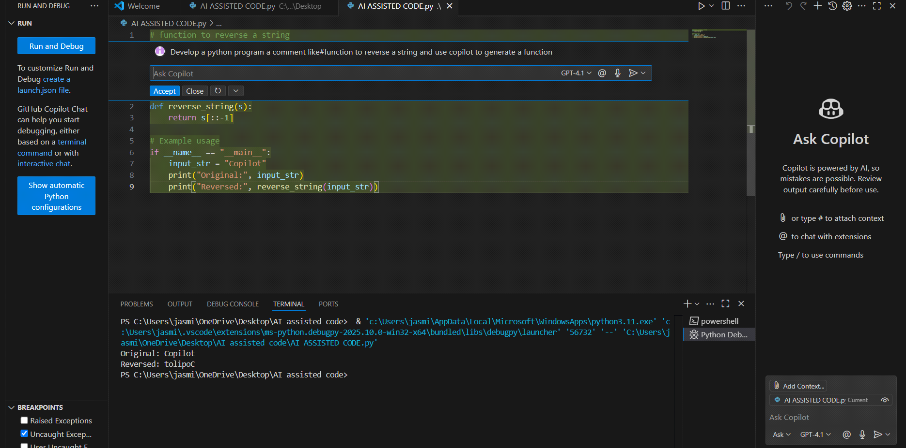

Task Description#4
>>Generate both recursive and iterative versions of a factorial functions using comments
Expected output#4
>>two working factorial implementation
PROMPT:
develop a python program to generate both recursive and iterative versions of a factorial functions using functions
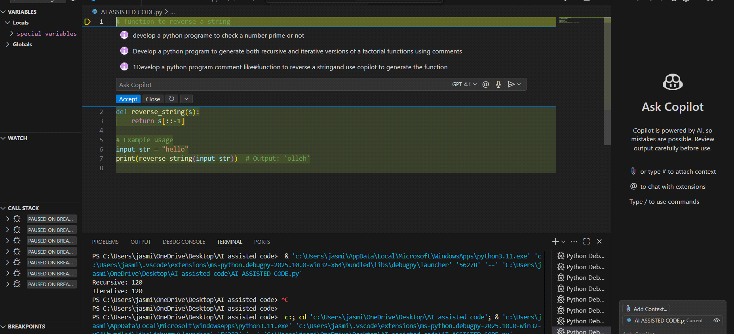

Task Description#5
>>use copilot to find the largest number in a list
assess code quality and efficiency
Expected output#5
a valid function with your review
PROMPT:
>>Develop a python program to find largest number in a list assess code quality and efficiency
